Inge Senekal

Theunis Kok: 43113877

Reuben Thorn: 41767500

Henk Mooiman: 4123584

Inge Senekal: 41218787

Ethan Sutherland: 38410737

Ruan van Heerden: 41763882

Analysis Document: Phase 3

Group 11

**Redefined Scope**

This was the previous scope:

* Maintenance of Clients
* Maintenance of Employees
* Maintenance of Units
* Maintenance of Activity-bookings
* Booking clients
* Checking clients in, at reception upon arrival - QR code
* Checking clients out after a visit.
* Booking events or activities for a client to attend
* Allocating staff to activities.
* Extensive reporting, including a report on the busiest period, and which 3 activities are the most popular among clients.

Due to normalization of our tables in the data model we realized that we can simplify the scope to have the following functionality:

* Maintenance of Clients
* Maintenance of Employees
* Maintenance of Units
* Maintenance of Activity-bookings
* Maintenance of Booking clients (This will include checking clients in at reception upon arrival and checking clients out) This will also include the booking of activities.
* Allocating staff to activities.
* Extensive reporting, including a report on the busiest period, and which 3 activities are the most popular among clients.

**Use Case Diagram**

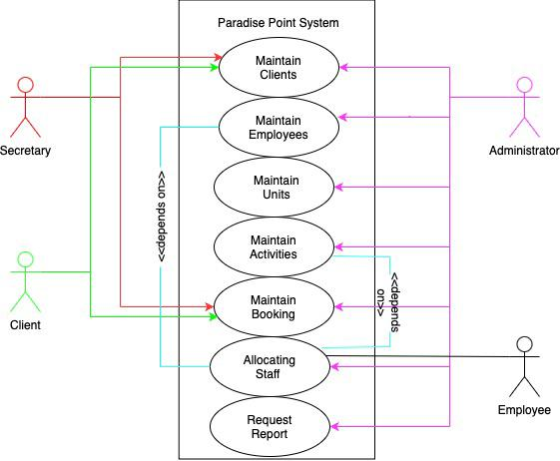

**Data Model**

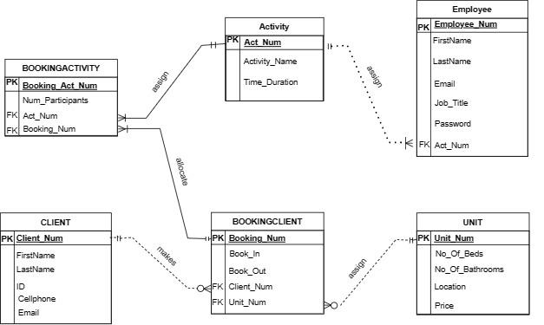

**Process Models**

**Client**

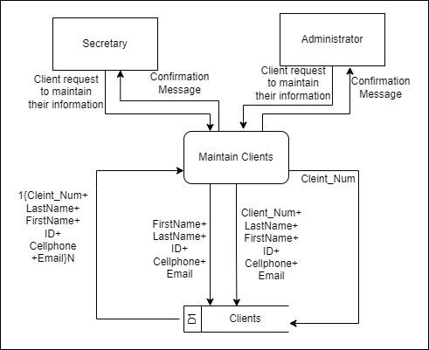

**Employee**

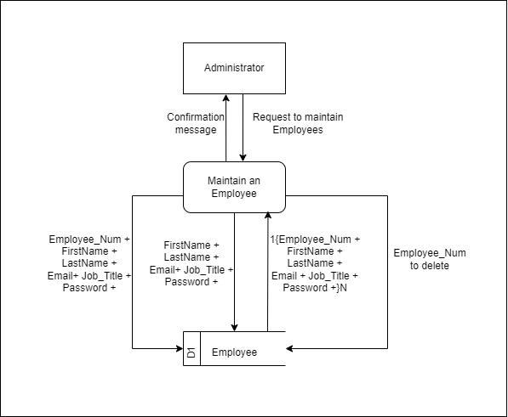

**Unit**

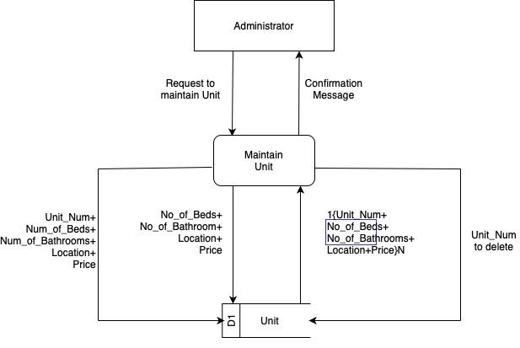

**Activity**

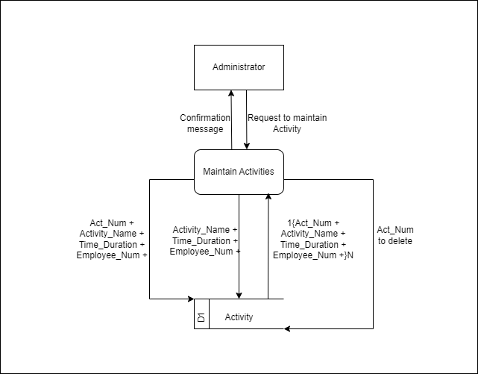

**Booking Client**

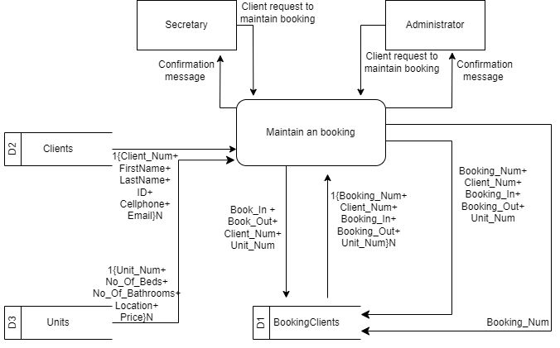

**Booking Activity**

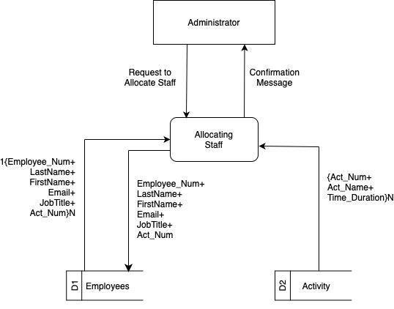

**Request Reports**

